Ellipsoidal Solids of Revolution

Definition
# Source: AI Source: Provided by: [Data Path: Persons Table -> ID Column: 1, Name_En Column: Motasem Essam] -> From: [ChatGPT] on [7/25/2026]
An Ellipsoidal Solid of Revolution is a three-dimensional solid generated by rotating an elliptical plane region around one of its principal axes.
The resulting solid is an ellipsoid of revolution, also known as a spheroid.
A spheroid has:
- One axis of revolution.
- A circular cross-section perpendicular to its axis of revolution.
- A curved ellipsoidal surface.
- A center of symmetry.
- Two equal semi-axes and one different semi-axis, except in the special case of a sphere.
Important distinction:
- Rotating an elliptical filled region generates a solid spheroid.
- Rotating an elliptical boundary curve generates only the spheroidal surface.

Geometric Representation
# Source: AI Source: Provided by: [Data Path: Persons Table -> ID Column: 1, Name_En Column: Motasem Essam] -> From: [ChatGPT] on [7/25/2026]
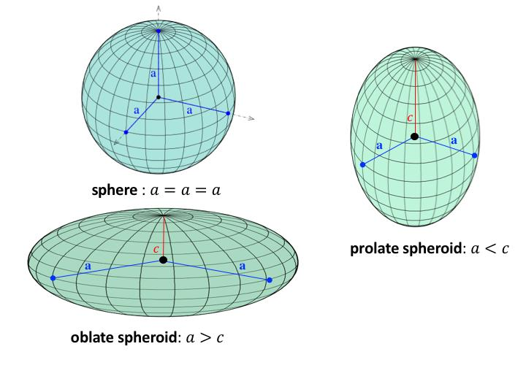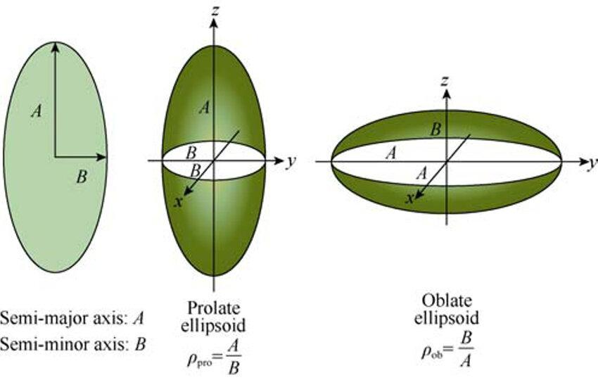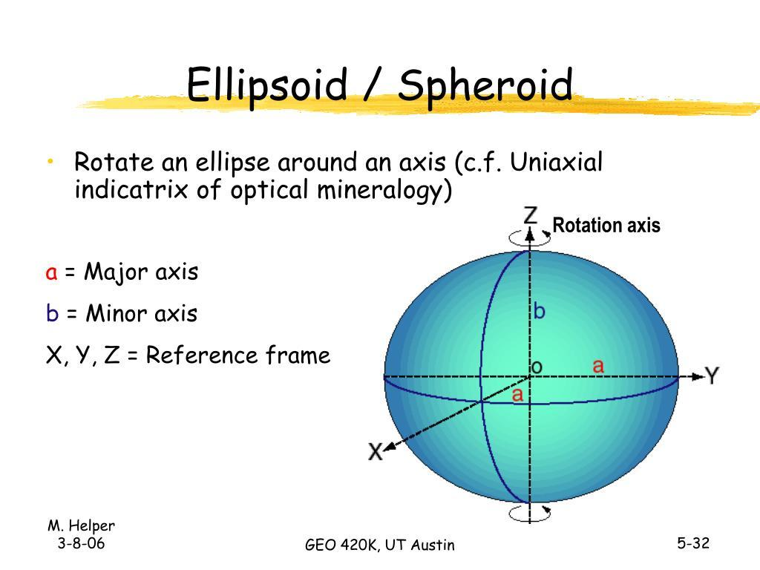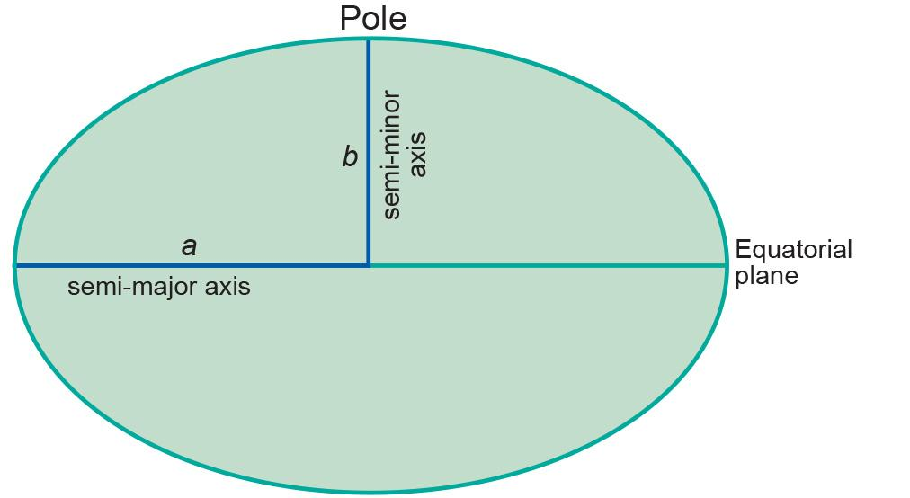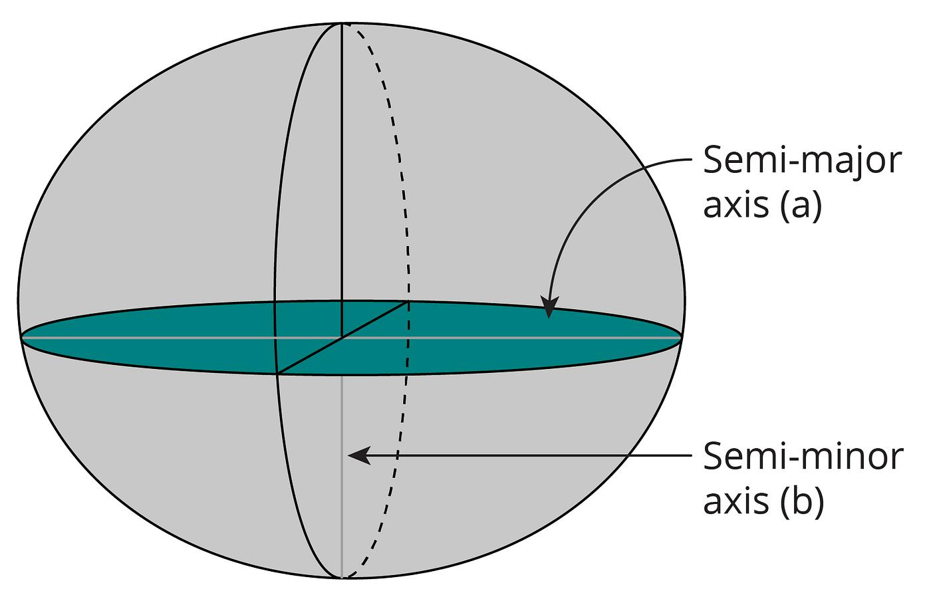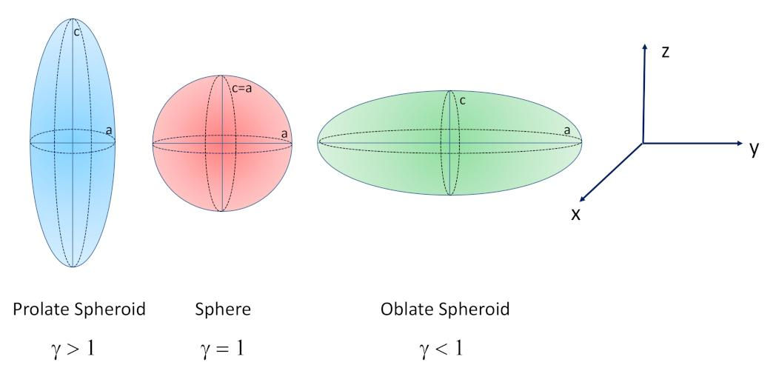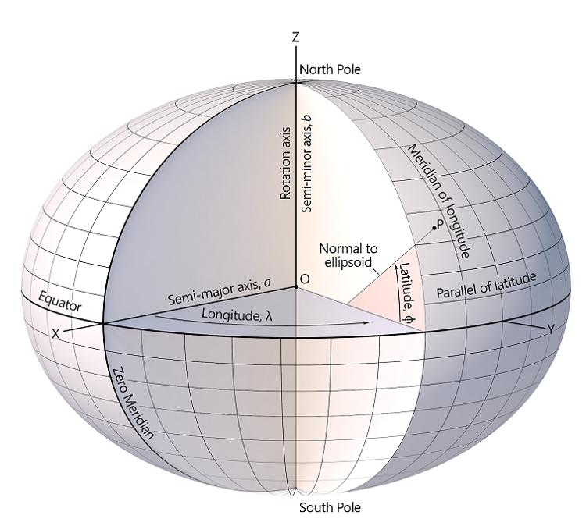

Geometric Structure
# Source: AI Source: Provided by: [Data Path: Persons Table -> ID Column: 1, Name_En Column: Motasem Essam] -> From: [ChatGPT] on [7/25/2026]
An ellipsoidal solid of revolution contains the following elements:
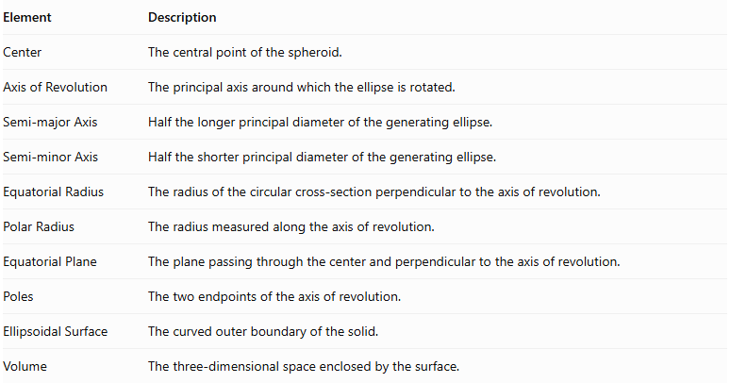
Element | Description
Center | The central point of the spheroid.
Axis of Revolution | The principal axis around which the ellipse is rotated.
Semi-major Axis | Half the longer principal diameter of the generating ellipse.
Semi-minor Axis | Half the shorter principal diameter of the generating ellipse.
Equatorial Radius | The radius of the circular cross-section perpendicular to the axis of revolution.
Polar Radius | The radius measured along the axis of revolution.
Equatorial Plane | The plane passing through the center and perpendicular to the axis of revolution.
Poles | The two endpoints of the axis of revolution.
Ellipsoidal Surface | The curved outer boundary of the solid.
Volume | The three-dimensional space enclosed by the surface.

Types of Ellipsoidal Solids of Revolution
# Source: AI Source: Provided by: [Data Path: Persons Table -> ID Column: 1, Name_En Column: Motasem Essam] -> From: [ChatGPT] on [7/25/2026]
Ellipsoidal solids of revolution are classified according to the axis around which the generating ellipse rotates.

Prolate Spheroid
# Source: AI Source: Provided by: [Data Path: Persons Table -> ID Column: 1, Name_En Column: Motasem Essam] -> From: [ChatGPT] on [7/25/2026]
A Prolate Spheroid is generated by rotating an elliptical region around its major axis.
Its shape is elongated along the axis of revolution.
Characteristics:
- The polar radius is greater than the equatorial radius.
- Its shape resembles an elongated sphere.
- Its two polar ends are farther apart than its equatorial diameter.
Mathematical condition:
$$a>b$$
Where:
- $a$ = semi-major axis and polar radius.
- $b$ = semi-minor axis and equatorial radius.
Equation:
$$\frac{x^{2}}{a^{2}}+\frac{y^{2}+z^{2}}{b^{2}}=1$$

Oblate Spheroid
# Source: AI Source: Provided by: [Data Path: Persons Table -> ID Column: 1, Name_En Column: Motasem Essam] -> From: [ChatGPT] on [7/25/2026]
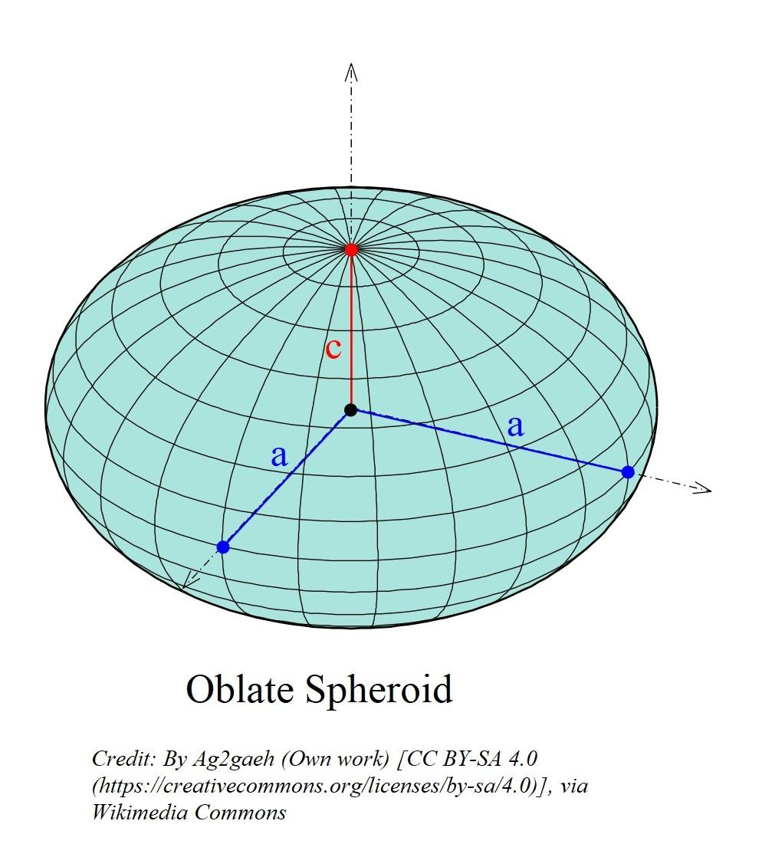
An Oblate Spheroid is generated by rotating an elliptical region around its minor axis.
Its shape is flattened along the axis of revolution and widened around its equator.
Characteristics:
- The polar radius is smaller than the equatorial radius.
- Its shape resembles a flattened sphere.
- Its equatorial diameter is greater than its polar diameter.
Mathematical condition:
$$a>b$$
Where:
- $a$ = equatorial radius.
- $b$ = polar radius.
Equation:
$$\frac{x^{2}+y^{2}}{a^{2}}+\frac{z^{2}}{b^{2}}=1$$

Sphere (Special Case)
# Source: AI Source: Provided by: [Data Path: Persons Table -> ID Column: 1, Name_En Column: Motasem Essam] -> From: [ChatGPT] on [7/25/2026]
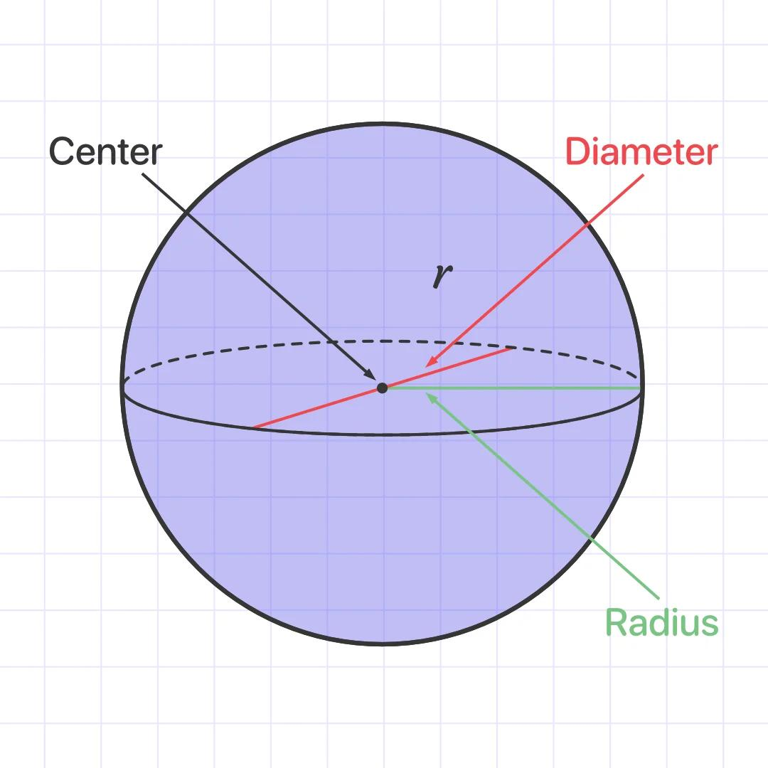
A Sphere is the special case of an ellipsoid of revolution in which the two semi-axes are equal.
It can be generated by rotating a circular region around any diameter, or an elliptical region whose semi-axes are equal around one of its diameters.
Characteristics:
- The polar and equatorial radii are equal.
- Every central plane cross-section is a circle of the same radius.
- It is perfectly symmetrical in all directions.
Mathematical condition:
$$a=b=R$$
Equation:
$$x^{2}+y^{2}+z^{2}=R^{2}$$

Mathematical Representation

General Ellipsoid of Revolution
# Source: AI Source: Provided by: [Data Path: Persons Table -> ID Column: 1, Name_En Column: Motasem Essam] -> From: [ChatGPT] on [7/25/2026]
Let:
- $a$ = equatorial semi-axis.
- $c$ = polar semi-axis.
- $z$ = axis of revolution.
The general equation is:
$$\frac{x^{2}+y^{2}}{a^{2}}+\frac{z^{2}}{c^{2}}=1$$
The relationship between the two radii determines the type:
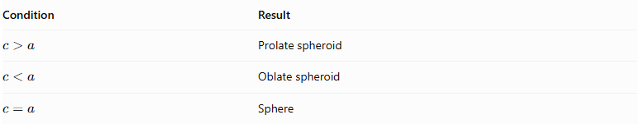
Condition | Result
$$c>a$$ | Prolate spheroid
$$c<a$$ | Oblate spheroid
$$c=a$$ | Sphere

Volume
# Source: AI Source: Provided by: [Data Path: Persons Table -> ID Column: 1, Name_En Column: Motasem Essam] -> From: [ChatGPT] on [7/25/2026]
The volume of an ellipsoid of revolution is:
$$V=\frac{4}{3}πa^{2}c$$
Where $a$ is the equatorial radius and $c$ is the polar radius.

Surface Area
# Source: AI Source: Provided by: [Data Path: Persons Table -> ID Column: 1, Name_En Column: Motasem Essam] -> From: [ChatGPT] on [7/25/2026]
Prolate spheroid
For $c>a$, define:
$$e=\sqrt{1-\frac{a^{2}}{c^{2}}}$$
Then:
$$S=2πa^{2}\left(1+\frac{c}{ae}\sin^{-1}(e)\right)$$
Oblate spheroid
For $a>c$, define:
$$e=\sqrt{1-\frac{c^{2}}{a^{2}}}$$
Then:
$$S=2πa^{2}\left(1+\frac{1-e^{2}}{e}\tanh^{-1}(e)\right)$$
Sphere
When $a=c=R$:
$$S=4πR^{2}$$

Mathematical Properties
# Source: AI Source: Provided by: [Data Path: Persons Table -> ID Column: 1, Name_En Column: Motasem Essam] -> From: [ChatGPT] on [7/25/2026]
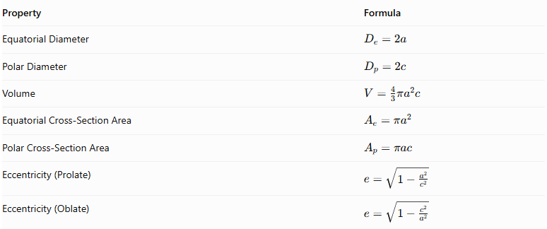
Property | Formula
Equatorial Diameter | $$D_{e}=2a$$
Polar Diameter | $$D_{p}=2c$$
Volume | $$V=\frac{4}{3}πa^{2}c$$
Equatorial Cross-Section Area | $$A_{e}=πa^{2}$$
Polar Cross-Section Area | $$A_{p}=πac$$
Eccentricity (Prolate) | $$e=\sqrt{1-\frac{a^{2}}{c^{2}}}$$
Eccentricity (Oblate) | $$e=\sqrt{1-\frac{c^{2}}{a^{2}}}$$

Cross-Sections
# Source: AI Source: Provided by: [Data Path: Persons Table -> ID Column: 1, Name_En Column: Motasem Essam] -> From: [ChatGPT] on [7/25/2026]
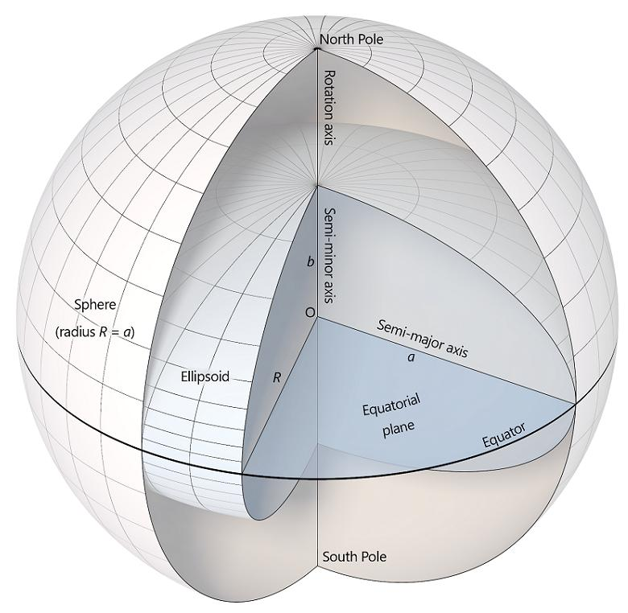
An ellipsoid of revolution produces different cross-sections depending on the position and orientation of the cutting plane.
- Equatorial Cross-Section: A circle with radius $a$, obtained by cutting through the center perpendicular to the axis of revolution.
- Axial Cross-Section: An ellipse obtained by cutting through the axis of revolution.
- Parallel Cross-Section: A circle obtained by cutting perpendicular to the axis at a distance $z$ from the center.
The radius of a parallel circular cross-section is:
$$r(z)=a\sqrt{1-\frac{z^{2}}{c^{2}}}$$
for $-c≤z≤c$.

Applications
# Source: AI Source: Provided by: [Data Path: Persons Table -> ID Column: 1, Name_En Column: Motasem Essam] -> From: [ChatGPT] on [7/25/2026]
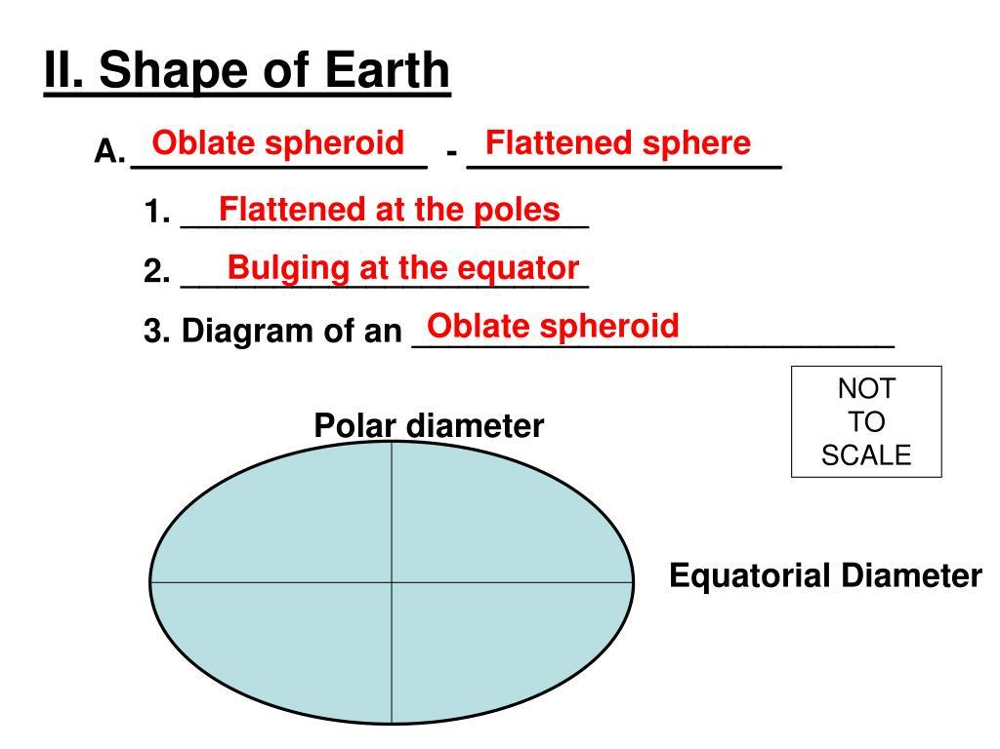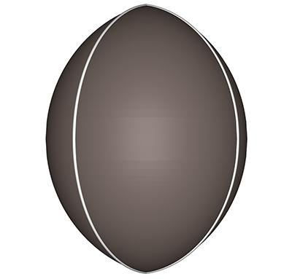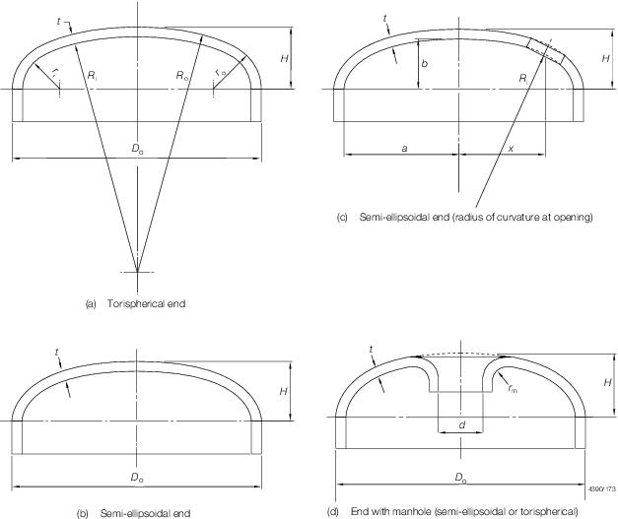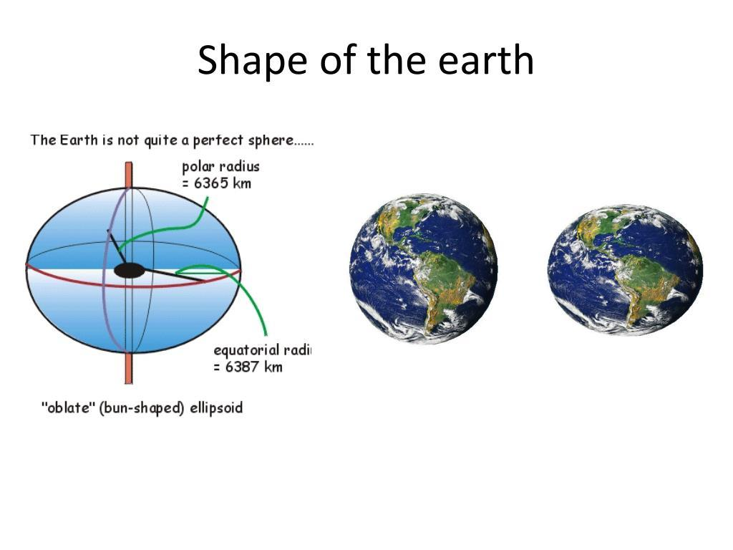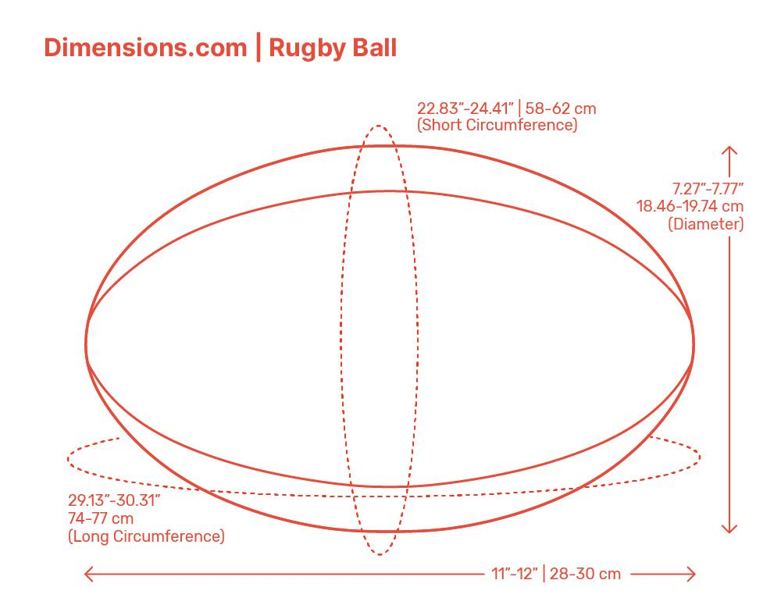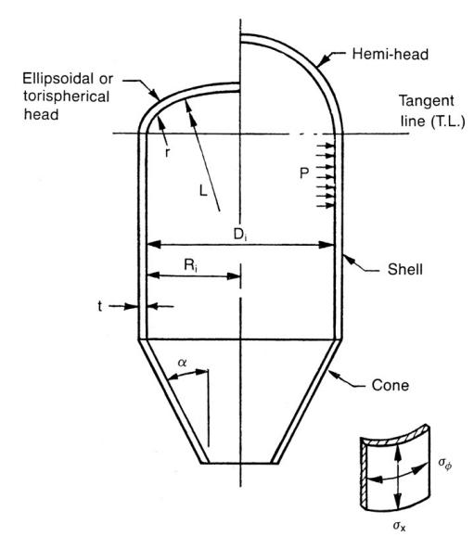
- Astronomy: Modeling the shapes of planets and celestial bodies.
- Geodesy: Representing Earth's approximately oblate shape.
- Engineering: Designing spheroidal tanks and pressure vessels.
- Physics: Modeling rotating fluid bodies.
- Aerospace: Studying streamlined and spheroidal structures.
- Mathematics: Studying surfaces, volumes, and rotational symmetry.

Comparison of Ellipsoidal Solids of Revolution
# Source: AI Source: Provided by: [Data Path: Persons Table -> ID Column: 1, Name_En Column: Motasem Essam] -> From: [ChatGPT] on [7/25/2026]
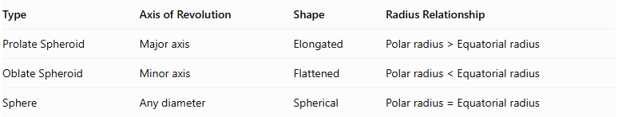
Type | Axis of Revolution | Shape | Radius Relationship
Prolate Spheroid | Major axis | Elongated | $$Polarradius>Equatorialradius$$
Oblate Spheroid | Minor axis | Flattened | $$Polarradius<Equatorialradius$$
Sphere | Any diameter | Spherical | $$Polarradius=Equatorialradius$$

Main Classification
# Source: AI Source: Provided by: [Data Path: Persons Table -> ID Column: 1, Name_En Column: Motasem Essam] -> From: [ChatGPT] on [7/25/2026]
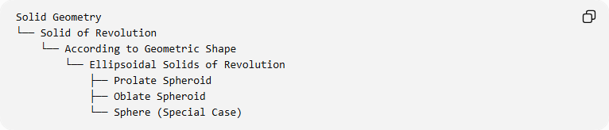
Solid Geometry
└── Solid of Revolution
└── According to Geometric Shape
└── Ellipsoidal Solids of Revolution
├── Prolate Spheroid
├── Oblate Spheroid
└── Sphere (Special Case)

Important Geometric Distinction
# Source: AI Source: Provided by: [Data Path: Persons Table -> ID Column: 1, Name_En Column: Motasem Essam] -> From: [ChatGPT] on [7/25/2026]
An Ellipsoid and an Ellipsoid of Revolution are related but are not identical classifications.

Solid | Description
Triaxial Ellipsoid | Has three unequal principal semi-axes.
Prolate Spheroid | Has two equal semi-axes and one longer semi-axis.
Oblate Spheroid | Has two equal semi-axes and one shorter semi-axis.
Sphere | Has three equal semi-axes.
A general triaxial ellipsoid cannot be generated by rotating a single ellipse around one of its principal axes. A spheroid has two equal semi-axes and is therefore rotationally symmetric.

Key Points
# Source: AI Source: Provided by: [Data Path: Persons Table -> ID Column: 1, Name_En Column: Motasem Essam] -> From: [ChatGPT] on [7/25/2026]
- Ellipsoidal solids of revolution are generated by rotating an elliptical region around one of its principal axes.
- A prolate spheroid is elongated along its axis of revolution.
- An oblate spheroid is flattened along its axis of revolution.
- A sphere is a special case in which all principal radii are equal.
- The volume formula is $V=\frac{4}{3}πa^{2}c$.
- A general ellipsoid with three unequal principal semi-axes is not an ellipsoid of revolution.

Conclusion
# Source: AI Source: Provided by: [Data Path: Persons Table -> ID Column: 1, Name_En Column: Motasem Essam] -> From: [ChatGPT] on [7/25/2026]
Ellipsoidal solids of revolution are three-dimensional solids generated from elliptical regions through rotation. Their principal forms are the prolate spheroid, oblate spheroid, and sphere. They are important in geometry, astronomy, geodesy, engineering, and mathematical modeling.

